The Orchard School proudly announces the
availability of The Orchard School Framework of Intent.

This comprehensive curriculum structure delivers detailed developmental information to support planning for meeting the learning needs and EHCP outcomes for SEND pupils working below age-related expectations from birth to end of Year 1 expected standards encompassing all key aspects of the EHCP framework.
Purchase and training are now
available!

The Curriculum - Developmental Steps
Following the 2016 Rochford Review the Orchard, like many schools, has moved away from P levels in favour of our own structure built around developmental steps and milestones. Our curriculum, which we call the ‘Orchard Framework of Intent’ links directly to the key areas of the EHCP: • Cognition: (Literacy/Maths/UW/EAD) • Communication and Language • Social and Emotional Development • Independence and self-care • Physical Development, and is firmly based on well-known sources of child development research, such as Mary Sheridan.
The framework is laid out as developmental steps, with a milestone statement for each key area at each developmental level. Currently there are 19 developmental steps ranging from birth – end of year 1 NC expectations. Each step is laid out as shown below. Steps 1-9 link to Pre-subject specific learning and step10+, to subject specific learning. For Sandwell schools, steps 1-9 precedes Sandwell Skills Ladders.
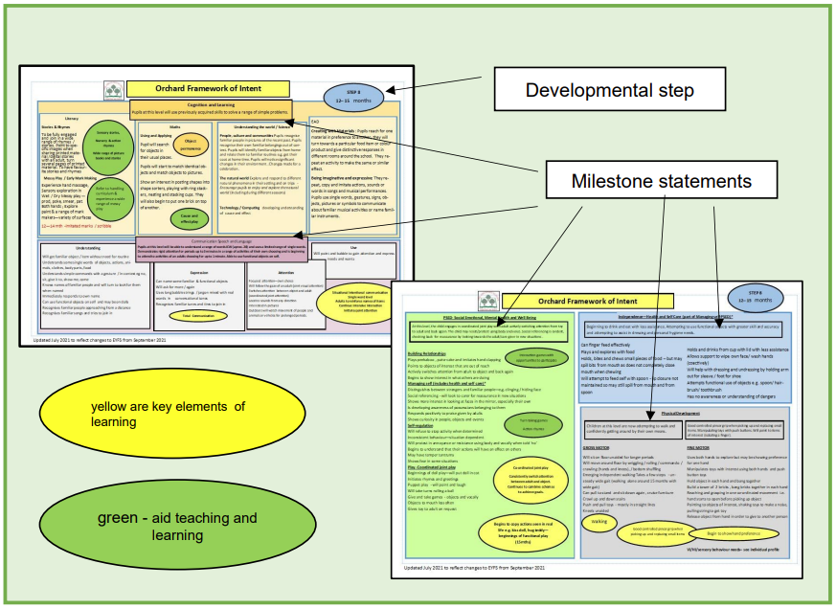
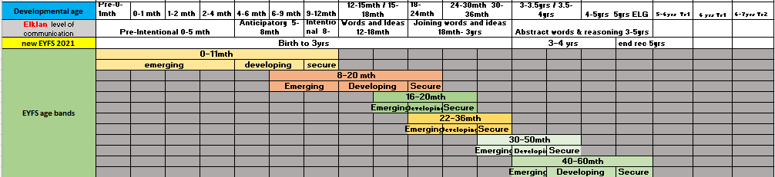
Each developmental ‘STEP’ of the framework gives an overview of ‘typical’ development at a specific age band, and this provides a sound guide to ensure that teaching and learning is developmentally appropriate and relevant, being pitched at just the right level for each child. Behind each ‘STEP’ there are a block of outcomes to achieve. These provide the focus for teaching and learning in each of the five areas and link to the key goals as outlined in each child’s EHCP. The following chart gives an approximate reference to the old P levels and show the age bands for each developmental STEP.
Each developmental framework step is supported by a comprehensive assessment framework which guides teaching & learning and enables the mapping of the smallest steps of progress. This particularly useful for pupils with complex learning patterns who need extended periods of time and a range of opportunities to learn important key skills, knowledge and understanding

For further information please see our website;
Orchard Framework of Intent (orchard.sandwell.sch.uk)

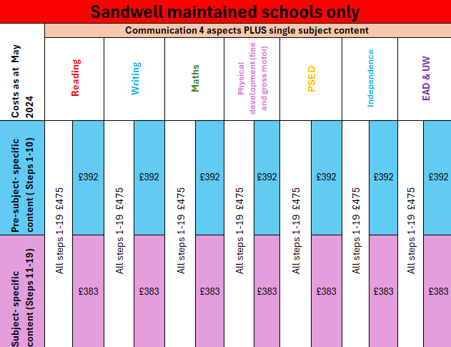
Prices apply to Sandwell Maintained Schools.
MAT and out of Borough schools P.O.A.
Main Package £2,200 MAT and out of Borough schools P.O.A.
Content;
19 -step framework developmentally ranging from Birth to end of Year 1 expectations PLUS curriculum small step assessment detail for all NC aspects
Introduction for SENCo +1 staff and 2-hour implementation visit within 1st term following purchase
Framework only £990 MAT and out of Borough schools P.O.A.
Content;
19 -step framework developmentally ranging from Birth to end of Year 1 expectations for all NC aspects
Introduction for SENCo
Assessment content only £1,400 MAT and out of Borough schools P.O.A.
Content;
19 -step small step content developmentally ranging from Birth to end of Year 1 expectations for all NC aspects
Introduction for SENCo
Communication & one single
subject; framework and small step content

Detail of content available
The whole curriculum framework and small step content- 19 step framework to end of Yr 1 expectations plus all small steps content for all curriculum aspects. Includes initial training for 2 staff and implementation follow up 2-hour visit within first term after purchase
Just the framework - 19 steps. Includes 1 hour introduction and implementation discussion
Just small steps - 19 steps. Includes 1 hour introduction and implementation discussion
Pre-subject-specific content - linked to engagement model Steps 1-10 framework & small steps
Pre-subject-specific content - linked to engagement model Steps 1-10 framework only
Pre-subject-specific content - linked to engagement model Steps 1-10 small steps only
Subject-specific content steps 11-19 supports Sandwell skills ladders and to end of Yr1 expectations framework & small steps
Subject-specific content steps 11-19 supports Sandwell skills ladders and to end of Yr1 expectations framework only
Subject-specific content steps 11-19 supports Sandwell skills ladders and to end of Yr1 expectations small steps only
Subject - related info; Framework and small steps
ALL options will come with communication aspects for chosen steps
Communication (4 aspects) & reading Pre-subject-specific steps 1-10
Communication 4 aspects) & reading Subject-specific steps 11-19
Communication 4 aspects) & reading all steps
Communication (4 aspects) & writing Pre-subject-specific steps 1-10
Communication (4 aspects) & writing Subject-specific steps 11-19
Communication (4 aspects) & writing all steps
Communication (4 aspects & maths Pre-subject-specific steps 1-10
Communication (4 aspects) & maths Subject-specific steps 11-19
Communication (4 aspects) & maths all steps
Communication (4 aspects) & physical development (fine and gross motor) Pre-subject-specific steps 1-10
Communication (4 aspects) & physical development (fine and gross motor) Subject-specific steps 11-19
Communication (4 aspects) & physical development (fine and gross motor) all steps
Communication (4 aspects) & PSED Pre-subject-specific steps 1-10
Communication (4 aspects) & PSED Subject-specific steps 11-19
Communication (4 aspects) & PSED all steps
Communication (4 aspects) & independence Pre-subject-specific 1-10
Communication (4 aspects) & independence Subject-specific steps 11-19
Communication (4 aspects) & independence all steps
Communication (4 aspects) & EAD & UW steps Pre-subject-specific 1-10
Communication (4 aspects) & EAD & UW Subject-specific steps 11-19
Communication (4 aspects) & EAD & UW all steps
Purchase and training are now
available!

